**2025-2026 Handbook**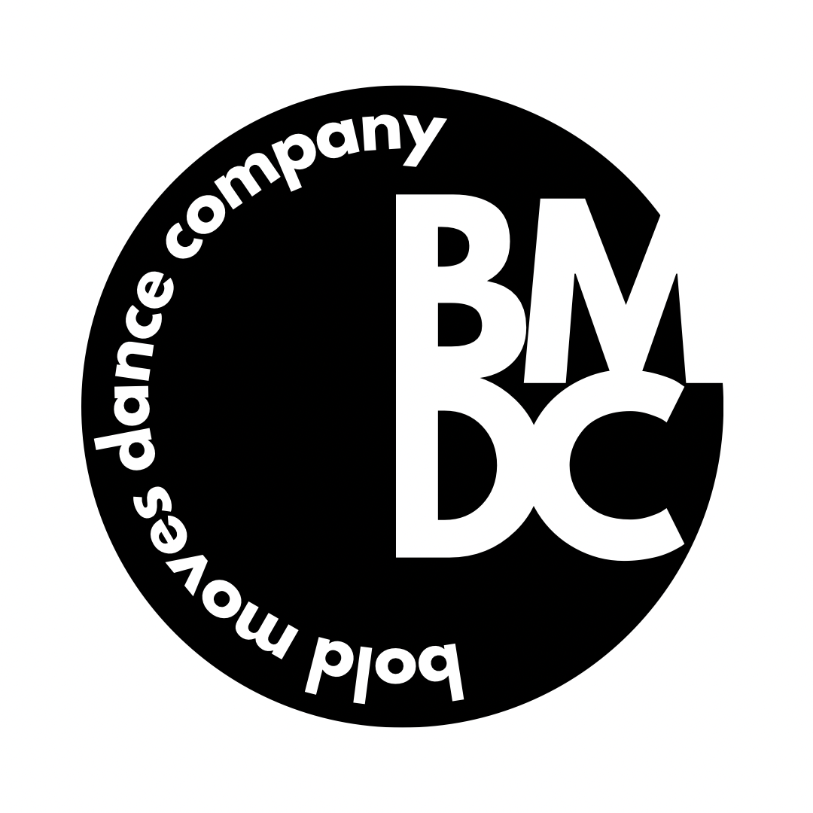

Recreational Classes

**Mommy and Me** is a 30-minute class structured to stimulate coordination skills, listening skills, balance, music interpretation, creative movement and motor development in the youngest dancers. Ballet positions and vocabulary is introduced. This program is an excellent introduction to the world of dance and lots of fun for Mom and dancer!

**Kinderdance** is a 45-minute class for students 3-5 years old where students learn ballet and tap technique, terminology, and musicality.

**Beginner Combo** is a 45-minute class for students 5 -6 years old. This class teaches the fundamentals of ballet and jazz with the focus on linking steps together with varying rhythms , proper foot articulation and body alignment.

**Advanced Combo** is a 1 hour class for students 6 -8 years old. This class expands on the fundamentals of ballet and jazz.

**Hip Hop** is a 30-minute class for students aged 5 to teen. A high energy class that uses the latest sounds in rap, R & B, and pop music together with movement influenced by today’s top choreographers. Age-appropriate music and movement is used for each class.

**Tumbling** is a 30-minute class for students 5-8 years old. This class teaches the basics of floor tumbling including forward rolls, back bends, cartwheels, round-offs and fundamental acrobatic strengthening and coordinating skills. This class does not participate in the recital.

**Acro** is an advancement from tumblethat combines strength, balance, and flexibility. Dancers will increase flexibility with our warm-ups by practicing splits, backbends, and more while also having the opportunity to use aerial silks under supervision of our instructors. This class does not participate in the recital.

**Ballet** serves as a backbone for many other styles of dance. Barre excersizes, center-work, across-the-floor combinations are taught to develop one’s turnout, alignment, as well as proper posture.

**Jazz** is based on ballet principles that often uses bold, dramatic body movements, including isolations and contractions, across the floor progressions, and current choreography all set to age-appropriate music.

**Tap** is a dance style that requires an understanding of timing and tempo. Emphasis is placed on precision, speed and clarity of sounds. Tap is great for developing musicality and coordination skills. Students will learn how to change their weight, count music, and use their shoes as an instrument.

**Contemporary** is a style of expressive dance that combines elements of several dance genres including modern, jazz, lyrical, and classical ballet.

**Lyrical** is an expressive form of dance that incorporates a fusion of ballet and jazz dance styles. In this class, dancers are encouraged to explore their emotions and movement through improvisation**.**

**Modern** dance resembles ballet in structure, using both parallel and turnout positions. The majority of movement comes from your core while emotions are expressed through contraction and release of the body.

**Pre-Pointe** beginner level pointe class for dancers her aspire to take pointe. Ankle and feet must be strong enough to support weight en pointe. Class will consist of strengthening and flexibility exercises to prepare dancer for pointe.

**Pointe** dancers begin their pointe studies in our pre-pointe classes to allow for a focused studies of very specific movement exercises. Focusing on core movement control and muscular strength throughout the season and ensuring the safety of each student as they progress in their strength and stability in class.

**Strength & Technique** is a combination class of leaps, turns, and flexibility taught in a technique class format. This class concentrates on proper placement, quick learning, strength and discipline.

**\*Private Lessons** are for those interested in working privately with an instructor on any dance style. The cost is $30 per 30 minute lesson. Please contact Holly Howe or front desk for information on instructor availability.

Performance/Competitive Company

**The Competitive Company** This is an audition based team which performs locally and competes regionally. Auditions are the 1st week of August each year to select the next year’s team. Ballet and jazz classes are required to be taken by all company students.

Competitive Company:

Tuition and Fees

$150 Monthly Tuition: Includes all weekly classes and any extra rehearsals. Each additional class is $10 each. Ballet and jazz are required class for all company members and are included in the cost of regular tuition.

**Tiny Company:

$100 Monthly Tuition

**Tuition (Recreational)** Sliding Fee Scale:

|  |  |  |  |  |  |
| --- | --- | --- | --- | --- | --- |
| **Class Time per week** | **Monthly Tuition** | **Class time per week** | **Monthly Tuition** | **Class time per week** | **Monthly Tuition** |
| 30 mins | $50 | 2 ¼ hours | $85 | 4 hours | $120 |
| 45 mins | $55 | 2 ½ hours | $90 | 4 ¼ hours | $125 |
| 1 hour | $60 | 2 ¾ hours | $95 | 4 ½ hours | $130 |
| 1 ¼ hours | $65 | 3 hours | $100 | 4 ¾ hours | $135 |
| 1 ½ hours | $70 | 3 ¼ hours | $105 | 5 hours | $140 |
| 1 ¾ hours | $75 | 3 ½ hours | $110 |  |  |
| 2 hours | $80 | 3 ¾ hours | $115 | Private Lessons | $60/Hourly |

**Payment:** Tuition is due by the 1st of each month and can be paid via auto-draft, cash or check, and online through our website. All accounts set up for auto draft will be drafted between the 1st and the 5th of the month. After the 10th of the month, a $10 late fee will be charged and enforced on all accounts past due. Additional fee of $10 will be applied if tuition is still not paid by last day of month. This also includes draft accounts that are denied for insufficient funds. Late notices will be sent via email. Checks can be made out to: Bold Moves Dance Company or BMDC. Tuition is not prorated for absences.

Tuition and Fees

**Fees**: Bold Moves Dance Company has three fees. They are listed below. All fees are non refundable.

|  |  |  |  |
| --- | --- | --- | --- |
|  | **Fee** | **Amount** | **Due** |
| 1 | *Registration Fee | $35 for all students | At time of registration |
| 2 | **Costume Deposit | See page 10 | Sept, Oct, & Nov (Company only)  November 1, 2024 (All dancers) |
| 3 | ***Recital Fee | On a sliding fee scale per number of dances in the recital **1-2 = $65 3-4 = $75 5-6 = $85 7+=$95** | March 1, 2026 |

**Notes Regarding Fees:**

*At Time of Registration: $35 Registration fee is non-refundable- NO EXCEPTIONS.

**Costume Note: If classes change, then costume amount will also change. Costume fees are approximate and are subject to change. Costume fees are non-refundable. No exceptions.

***Recital Fee**:** Students are assumed to be performing in end of year recital unless they have opted out in writing. Students who wish to opt out of the recital performance must do so for all of their classes.

.

*\*We will have classes on school’s teacher workdays. In the case of inclement weather, there will be information on Facebook/Instagram pages and an email alert will be sent.*

Important Dates

|  |  |
| --- | --- |
| **Important Date** | **Studio Information** |
| Monday, September 8th | Classes Begin |
| July 1, Aug 1, Sept 1 | Costume deposit due (Competitive Company Only) |
| October 25th | Seaboard Festival  Hamlet, NC |
| November 1 | Costume deposit due -ALL DANCERS |
| November 26 & 27 | Studio Closed for thanksgiving break |
| December 5th | Hamlet Christmas Parade/No Classes |
| Dec 22-Jan 2 | Studio Closed for winter break |
| March 30-April 2 | Dance Picture Week |
| April 1 | Recital Fee Due |
| April 6-10 | Studio Closed for Spring Break |
| May 16 & 17 | Rehearsal & Recital |

**Recital 2026 Dates**

Rehearsal and Recital will be held at The Cole Auditorium

Date: May 16th & 17th 2026!

STUDIO POLICIES

Tuition and Registration Fees

1. **Registration Fee:** A $35 non-refundable registration fee per student is due at time of registration.

**Tuition Late Fee:** Tuition is due by the 1st of each month and can be paid via auto-draft, cash or check, and online through our website. All accounts set up for auto draft will be drafted between the 1st and the 5th of the month. After the 10th of the month, a $10 late fee will be charged and enforced on all accounts past due. Additional fee of $10 will be applied if tuition is still not paid by last day of month. This also includes draft accounts that are denied for insufficient funds. Late notices will be sent via email. Checks can be made out to: Bold Moves Dance Company or BMDC. Tuition is not prorated for absences.

1. **Pro-rated Months:** September through May will be charged a full month’s tuition. Whether the month is short (3 weeks) or long (5 weeks), tuition remains the same. Tuition is not pro-rated for absences. Your dancer(s) is encouraged to attend makeup classes for missed classes. Please refer to the absenteeism and inclement weather section.
2. **Sibling Discounts:** A 20% discount will be taken off the entire tuition bill for families with more than one dancer.
3. **Methods of Payment:** BMDC accepts personal checks, credit cards, debit cards, and cash as methods of payment. One-time payments may also be made on our website. If you pay in cash, please give it to an office staff member and receive a receipt. If paying by check, credit card, or debit card, please write the student’s name in the memo section of your check or at the top of the receipt. Checks should be made payable to “Bold Moves Dance Company” or “BMDC”. WE DO NOT ACCEPT APPLE PAY AT THIS TIME.
4. **Auto-Draft:** BMDC offers auto draft from debit cards and credit cards.

Class Schedule

For the most updated version of our class schedule please visit www.boldmovesdancecompany.com or visit the front desk.

Schedule Changes

1. **Class Changes:** A student may drop and add classes depending on availability. To ensure proper costume orders, class changes will not be allowed after November 30.
2. **Withdraws:** A student wishing to drop all their classes is considered to be withdrawing from the studio. Parents are required to give a 30-day written notice and are responsible for 30 days’ tuition. A student not showing up for classes does not constitute a withdrawal.
3. **Waitlist Policy:** Students desiring placement in a full class will be placed on a waitlist.

STUDIO POLICIES

Student Class Placement

1. **Age Groups**: All classes are based on the student’s ability not age. Teachers have discretion over all class placement.

Student/Parent/Teacher Relations

1. **Contacting Instructors:** Instructors can be contacted via email. Please do not try to catch an instructor between classes. Class schedules are very tight and our instructors would like to give your questions and concerns the proper attention.
2. **Social Media:** We are on Facebook and Instagram! Become a fan and keep up with latest BMDC news!
3. **Phone Calls:** You may leave a message for a teacher at the studio. Due to varied work schedules, emails are best.
4. **Disruptive Behavior:** Disruptive behavior will not be tolerated. If this occurs repeatedly, the parent will be contacted. If it continues, the student will be dismissed from class that day.
5. **Opening Class Doors:** Please respect our instructors. All classes are closed session. Do not open the door during class time. When classes are over, the instructor will open the door for the next class to enter and students will exit to the lobby.
6. **Parent Observation:** We have a live video feed in our lobby for parent observation. Parents are NOT allowed in the dance rooms at any time.
7. **Emails from Studio:** All registered accounts will automatically be enabled to receive email updates and alerts from the studio. Please note that that if you do not check your email this means you will mean you will miss out on important studio reminders and announcements.

Absenteeism & Inclement Weather

1. **Illness Policy:** Parents are advised to keep their students at home for the following conditions:
   * Pain – any complaints of unexplained or undiagnosed pain.
   * Runny nose (green mucus indicates infection), watery eyes, coughing, sore throat, or productive cough.
   * Difficulty in breathing   
      – wheezing or a persistent cough).
   * Fever (100°F/38.3°C or more) or Nausea and vomiting.
   * Infected skin or eyes or an undiagnosed rash. Severe itching of body and scalp.
   * Unexplained diarrhea or loose stool combined with nausea, vomiting, or abdominal cramps. These may indicate a bacterial or viral infection that is easily passed from one child to another.
   * Children with known or suspected communicable diseases or lice.
2. **Missing Classes:** If a student will be missing 2 or more consecutive weeks of class, please contact the studio office. The office staff will relay the information to the instructors.
3. **Excessive Absences:** Students with excessive class absences may be pulled from the recital dance with no refund. This is at the teacher's discretion.
4. **Inclement Weather:** In the case of inclement weather, there will be information on Social Media. We will also send an email notification
5. **Make Up Classes: There are no refunds for missed classes whether it is due to student absence or studio closure. These can be made up any time before May in an age appropriate class.**

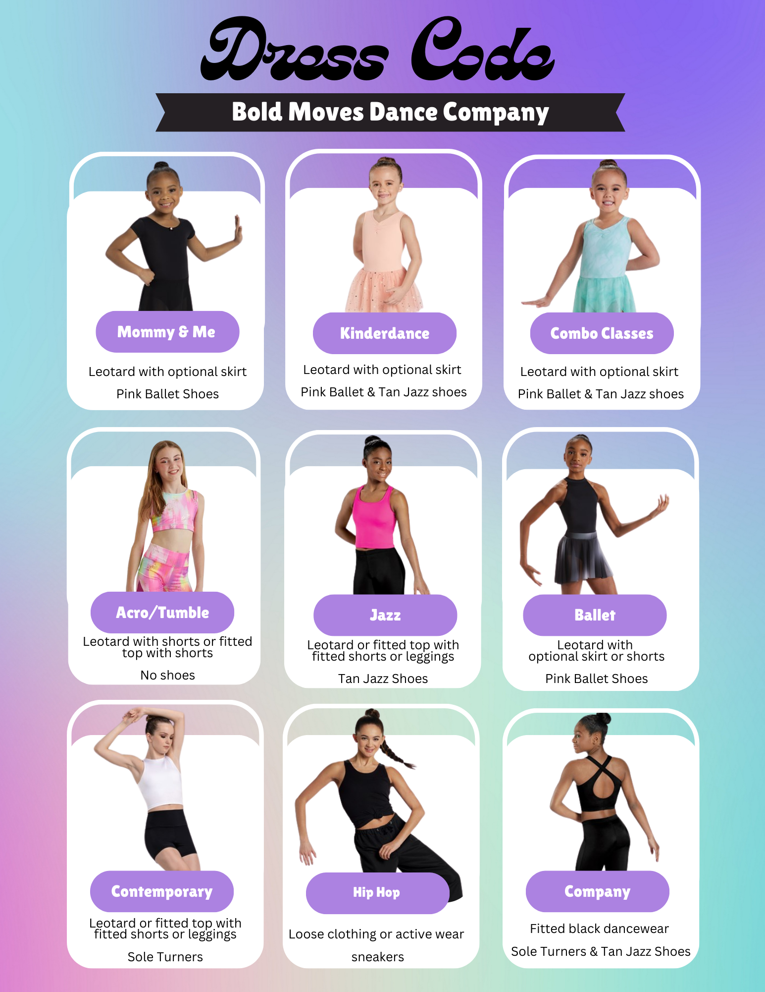

STUDIO POLICIES

Student Dress Code

1. **Shoes:** Proper shoes in specific colors are required for all classes. A list of shoes can be found below and can be ordered through BMDC.
2. **Hair:** Hair should be pulled up and away from the student’s face.
3. **Acceptable Dancewear:**

STUDIO POLICIES

Waiting Room & Lobby Rules

1. **Hallways Must Be Clear:** Per the Fire Marshal code, there is no sitting or standing in the hallways. Please remain in the lobby area while waiting for class to begin or let out.
2. **No Horseplay:** Parents are asked to keep students and waiting siblings from aggressive horseplay in the waiting areas.
3. **No Acrobatics:** Students should not be performing any acrobatics in the halls or waiting areas.
4. **No Food:** Absolutely no food is allowed in the dance rooms. No drinks, sodas, coffee, gum, or food of any kind is allowed in the main studio areas.
5. **Student Drop Off:** Students should not be dropped off earlier than 10 minutes prior to class or stay longer than 5 minutes afterwards. Please walk your student in or make sure they have gone inside their dance room before leaving. Students must remain inside the studio until their ride arrives. Students left 5 minutes past their class end time without a call or notification are subject to a $10 charge.
6. **Parking Lot:** No student of any age should hang out in the parking lot without a parent present.
7. **Leaving the Studio:** No student is to leave the studio without a parent’s permission. This includes during any breaks the student may have between classes. Students who leave the facility unsupervised are solely responsible for themselves and must have a waiver signed by his/her parent.
8. **Time Between Classes:** Young students (age 6 & under) should not be left unattended between classes.
9. **Be Courteous:** Please be courteous to fellow parents. Our waiting areas can become crowded and a little common courtesy can go a long way.

Personal Belongings

1. **Labels:** Please label all shoes, dancewear, dance bags, coats, etc. with the students **FIRST and LAST NAME.** Please write your dancer’s name on the bottom of their shoes. If not labeled properly, teachers will write your dancers first and last name on their shoes during the first few weeks of classes. If the item left behind is properly labeled, the studio will attempt to contact the parent and hold that item in the studio office.
2. **Lost & Found:** The lost and found basket is located in the office area. Unclaimed items will be donated at the end of each month. Please check lost and found bin regularly. BMDC is not responsible for lost or stolen items.

Photography Release

Permission is granted to Bold Moves Dance Company (BMDC) to use and publish for editorial, trade, advertising or other promotional purpose all photographic, video, and digital images of BMDC students, including names in conjunction with Studio and School Name. All parents who do not wish their child’s image or name to be used in this manner must declare so in writing. Please submit your written disapproval to the office.

Medical Insurance

Bold Moves Dance Company does not carry medical insurance for its students. It is required that all dance students be covered by their own family insurance and if injury occurs it is understood that the student’s policy is the only source of reimbursement.

Class Prep & What to Expect

Preparing for Class

1. Dancers are to enter the dance studio fully dressed for class with their hair properly pulled back (bun for ballet) and dance shoes on. Please do not wear street shoes into dance rooms. Dance bags may be brought into the room. Please mark FIRST & LAST name on shoes & dance bags.
2. Kinderdance & Combo classes will need to have their ballet shoes on each week when entering class. Please put tap or jazz shoes in a dance bag that they will bring in with them. Please mark FIRST & LAST name on shoes & dance bags. Teachers will help dancers change shoes in the middle of the class.
3. Please be sure all phones and electronic devices left in your dancer’s bag have their ringers and sounds set to silent.

What to Expect Your First Week

1. The halls are very crowded the first few weeks of classes. This will settle down.
2. Several room & Class Changes occur during the first month of the new dance season. Please be patient. Classes often have to change at the same time, so that dancers can go to the different styles they are taking.
3. Like school, the first few weeks of class are review. This allows everyone to get comfortable with new classes and new teachers. Also, teachers can evaluate students to be sure they are in the correct class.
4. If dancers have been placed into classes that are not correct for them — Don’t worry — we will find a more suitable class!
5. Parking is the #1 complaint with parents in dance schools around the nation. This is something that can’t be helped. Please be careful to watch for children! Please do not allow your children to cross the road by themselves; safety is our first priority for all of our dancers.
6. It is best to get your dancer in class on time and ready to dance.
7. Please keep the hallways clear; dancers will be walked out into the main lobby for pick up.
8. The youngest dancers will often have tears or anxiety the first few weeks. This is normal. Our teachers are trained to get children “on task” quickly. It is not uncommon to have a few dancers on a few hips the first month of class! The best way to ensure success is for parents to assure them they are going to have fun. Leave as quickly as possible and make sure the door closes behind you.
9. Please keep noise down at the window, in the lobby, and hallways. Don’t let siblings open the door or knock on the window or door. This will distract the dancers.
10. Please have all dancers use the bathroom before class. Teachers will gladly take them if they do need to go during class, but this can be a disruption.
11. You do not have to stay at the studio while your child has a class. However, you must be here to pick your child up on time. If you are running late, please call the studio so that we can get them to the office to wait for you.

**Please email us with any concerns. We want your experience to be a positive one!**

**3. Will there be someone taking pictures during the recital?**  Yes! We will have a photographer taking photos during the recital. You are welcome to take photos but flash photography is not permitted.

**4. What if my dancer needs a costume change?** You are responsible for changing your dancer. Back stage moms will be assigned for each class to bring them back stage but will not be responsible for getting your dancer changed.

FAQ’s

**1. Will there be a recital video to purchase?** Yes. Order forms for recital USBs will be in the lobby during April & May. Cost is $35

**2. Does my dancer get a trophy?** Depending on the number of years your dancer has been with BMDC they will receive either a medal or a trophy.

All About Recital

Recital Fees

**Recital Fee:** The annual recital fee per student is due April 1, 2026. The recital fee covers the cost of the auditorium and recital programs. This fee also allows students to invite as many guests as they like by eliminating ticket sales. All recital fees are non-refundable.

**Number of dances = Recital Fee 1-2 = $65 3-4 = $75 5-6 = $85 7+=$95**

Costumes

**1.** **Costume Fees:** Costume amounts are approximate and subject to change. Changes in a student’s schedule can result in a change of costume and costume fees. Costume amount includes costume, tights and shipping. Once costumes are ordered balances will be sent home. Example: Costume deposit paid in November $75, remaining balance paid in February $35.All Costume fees are non refundable.

1. Mommy and Me class will perform a ballet dance and have one costume
2. Kinderdance and Combo classes will perform both ballet and either jazz or tap numbers in the recital, and will have two costumes or a combo costume.
3. Tap/Jazz classes will only have 1 costume or a combo costume.
4. Ballet classes will have 1 costume.
5. Tumbling & Acro **will not** participate in the recital and will not have a costume fee.
6. Hip Hop classes **will not** be charged a costume fee. Costumes will be self-bought based on guidelines set by instructor.
7. Company teams will have 3-5 costumes excluding solo, duet, and trio costumes if applicable.

**Costume Deposits**

**Mommy and Me:** $75 **Kinderdance/Beginner/Advanced Combo:** $95 **Ballet/Jazz/Contemporary:** $95

**2.Payment Due Date:** Costumes deposits are due for recreational students are due November 1st. Costume deposits for company students are due October 1 & November 1.